Now we are going to learn how we will use section list. We have seen many examples like Flatlist , custom list with map but Selection list is different form this. How if we have array inside another array means there is nested array then you can use section list to show it. How you will come to know about it



Lets start with our points as shown above

First for our section list we will make an array where we will keep username and inside it we make another array inside which there will be skill s of the user (who knows)

Then we will use the section list where we will render item and we will also render Header (who knows)

And we will render nested array

At last we will discuss some interview question related to section list , custom list and Flatlist

**Note:-**

Id plays an important role here while looping

SO now our data will look like below

const users = [

  {

    id:1,

    name:'Anil',

    data : ['PHP' ,'Angular' ,'React js']

  },

 ]

Here the array contains the object containing user information like his name ,id, and skill s he has

And and object contains an array telling the skills that object representing the user has

Here one thing you could ask is that the data key in the object does we have have to use name “data ” it could not we use another name. like skills or programming_Language

Teacher could not find the answer whatever he could see in official documentation or in community sites there it is written that you have to use the data key here you could not use another key (as this data will be section list) even you could change the name or id but If you are taking an array in a nested array. You have to use data here. Most probably in future it may become dynamic

Now we will take name as a Header(Who knows)

And inside it the data we will see will be of data key

So to do it and traverse through this. First of all we need to is that you have to use section list

We will import it from react native that is selection list

And use it in jsx

  return (

    <>

    <Text style={{fontSize:31}}>

      Section List in React-Native

    </Text>

   <SectionList/>

    </>

  );

Now we need to pass some parameter or props you could also add style to it. We add props sections we will give here and section will be whatever data we have made that is users array

We already some data in the user as shown below

 const users = [

  {

    id:1,

    name:'Anil',

    data : ['PHP','Angular','React js']

  },

  {id:2,

    name:'Peter',

    data : ['Java','Js','HTML']},

  {id:1,

    name:'Anil',

    data : ['C','C++','Python']},

  {id:1,

    name:'Anil',

    data : ['CSS','BootStrap','HTML']}

 ]

So we pass users array to the section as shown below

   <SectionList section={users}/>

And next thing will be renderItem prop

You will find this renderItem prop in the Flatlist

Its work is similar here

We will pass it the callback function returning Components Now it will look like below

<SectionList sections={users} renderItem={({item})=><Text style={{fontSize:31}}>{item}</Text>}/>

Now if you see the output then it will look like below

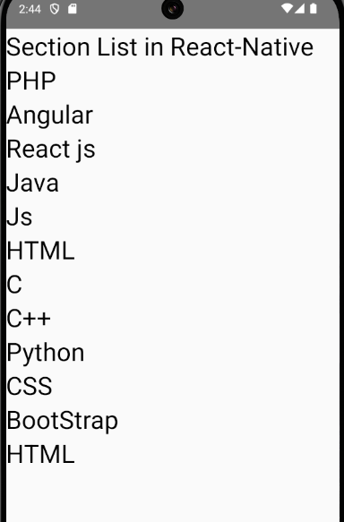

Now you can see all the data that was present in the inner array that was stored inside data key of the object but they kind of look like a single list because its header is not printed yet.

**Note:-**

I think in the backend what is happening by the logic of code in the list is that every object in the outer array is read by accessing its data key and then give each element of each data key in different objects who are member of the outer array to the callback function that was passed to the renderItem props.

To print its header you need to pass another prop to the renderSectionHeader props like we did with render item similarly we need to do here

But in the callback we need to tell what to select for the data of our Header ( meaning what key to take from the object member of outer array ). Suppose we want to print name as a Header

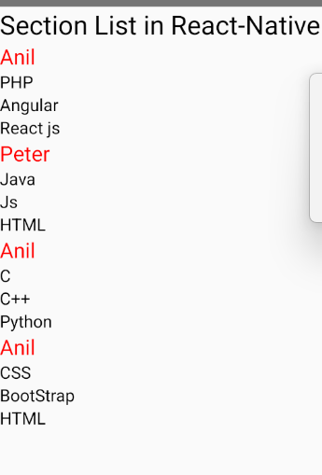

7:10

In the style for renderSectionHeader we set the color for red color and we set its

Now we give margin of 20 to renderItem

Now it look like as a screen below

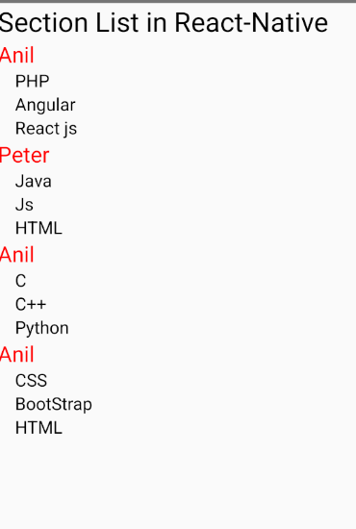

So that is the use of Section list but we have to set the key data to indicate list that we are going to print in Section list who knows with upcoming time they mat change it that we can give dynamic key in future

In interview you could be asked that can we make nested list with custom list and flatlist yes we can but section list give us by default option to make such nested list

Flatlist does not give you by default such option and in the custom list we can make with the help of map function there we do all the things manually

Second thing they could ask you where to use Flatlist and Section list

You will say you have single array you need to print each value you use Flatlist

Where you have nested list you use Section list there Alright that’s all for this lesson.